Client + Freelancer

Need to set up email verification method for both.

**Query: Please let me know about this. New registration mail ?**

**Reply : Yes once registration is done then need to send email verification to the user mail ID with link , once user click on that link then can able to land on login page, & able to login with the the sign up credentials.**

Freelancer

Profile title must be having skill so this can help to get project & search freelancer by client.

Query: Please let me know you want search with client title mean client name ?

Reply : I want freelancer profile title with skill base.

Client

All skill should be dynamic so if client enter any unknown skill which is not present in database .so

the unknow skill should be adding while post job.

**Response: This is done**

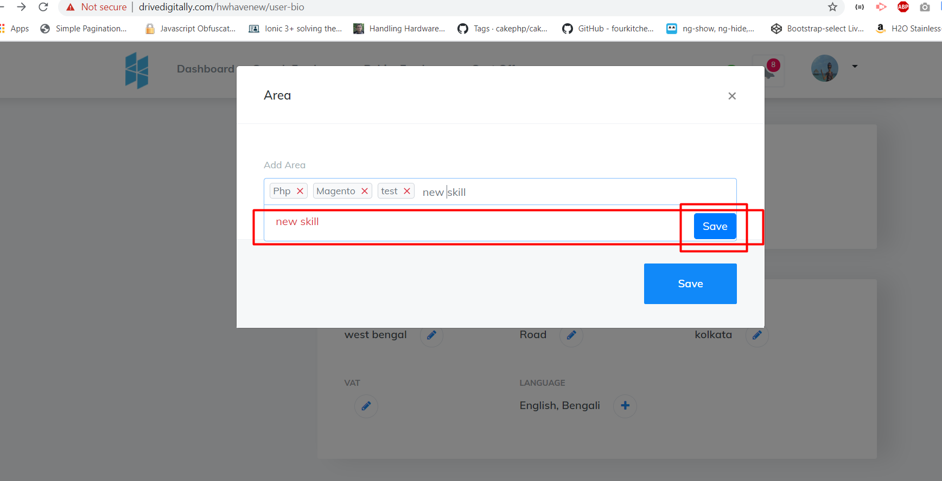  
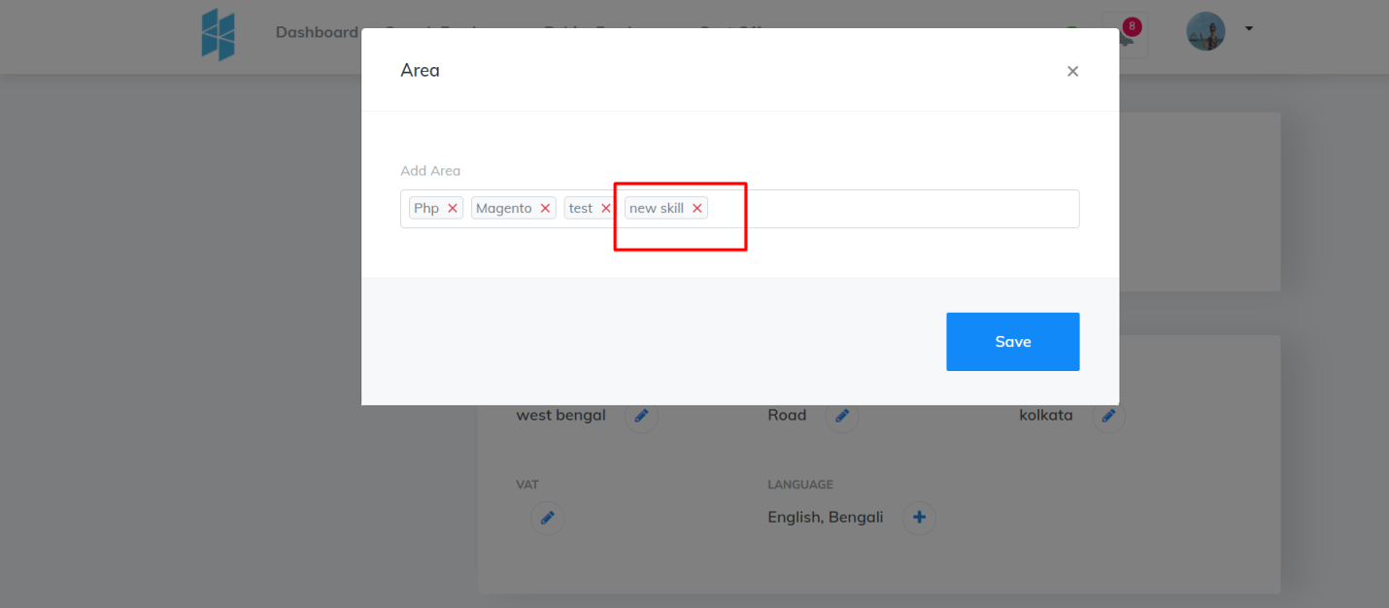

http://www.drivedigitally.com/hwhavenew/search-freelancer

Search should be based on skill only.

**Response: This is done**